Name: 6th Grade Math Homework August 17 – 21

Please use your math notebook and/or our math website for help/videos to help with concepts on this homework.
6th grade math website: sms6math.weebly.com SHOW ALL WORK IN THE WORK COLUMN.

Monday | Monday’s Work | Tuesday | Tuesday’s Work
Find the sum.  637,391 + 372,088 |  | Find the sum.  4,589 + 609
Find the difference.  256,805  - 136,667 |  | Find the difference.  8,428 - 837
What fractional part is shaded below? |  | What fractional part is shaded below?  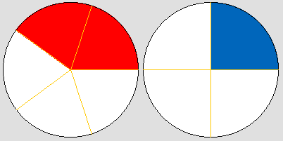
Find the product.  25 x 16 |  | Find the product.  34 x 56
List all of the factors of 8. |  | List all of the factors of 20.
If there are 12 inches in a foot, how many inches are in 4 feet? |  | If there are 3 feet in 1 yard, how many feet are in 9 yards?
Solve.  3² |  | Write 5 x 5 x 5 x 5 as an exponent.
Solve using the order of operations.  2 x 4 + 3 x 5 |  | Solve using the order of operations.  12(6 + 4) – 2

Wednesday | Wednesday’s Work | Thursday | Thursday’s Work
Find the sum.  84,396 +29,760 |  | Find the sum.  67,008 + 38
Find the difference.  73,850  - 23,559 |  | Find the difference.  63.15  - 2.04
What fractional part is shaded below? |  | What fractional part is shaded below?
Find the product.  124 x 6 |  | Find the product.  678 x 13
List all of the factors of 21. |  | List all of the factors of 24.
If there are 5280 feet in a mile, how many feet are in ½ a mile? |  | If there are 36 inches in a yard, how many inches are in ½ a yard?
Solve.  2⁵ |  | Write 12 x 12 x 12 as an exponent.
Solve using the order of operations.  13 + 4(6 – 5) |  | Solve using the order of operations.  22 ÷ 11 – 1 x 2

